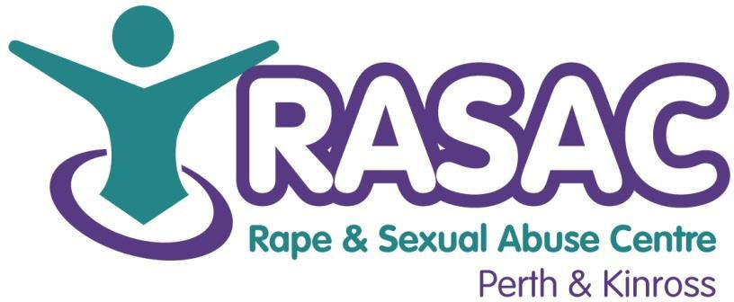

Sexual Violence Prevention Worker

Information Pack

RASAC P&K, 16 King Street, Perth, PH2 8JA
01738 626290 www.rasacpk.org.uk admin@rasacpk.org.uk Registered Scottish Charity SC037982/Company Limited by Guarantee Number SC389959

Thank you for your interest in working with RASAC P&K.

This pack includes guidance on how to complete the application form alongside some additional information about RASAC P&K and our recruitment process. We suggest that you read all information enclosed very carefully before submitting an application.

Please do not send CVs as they are not an acceptable alternative to any part of the application form and will not be considered.
In light of the current situation with COVID-19, we are asking that wherever possible completed application forms are e-mailed to recruitment@rasacpk.org.uk. Please be aware that postal deliveries may take longer at this time. If you are able to return your completed forms by email please be assured that all personal information will be separated immediately, and treated in the strictest confidence.

Equalities monitoring forms can be posted in a confidential envelope to RASAC P&K, 16 King Street, Perth, PH2 8JA.

The closing date for completed applications is 12 noon, Wednesday 9th June 2021. We regret that late applications cannot be accepted.
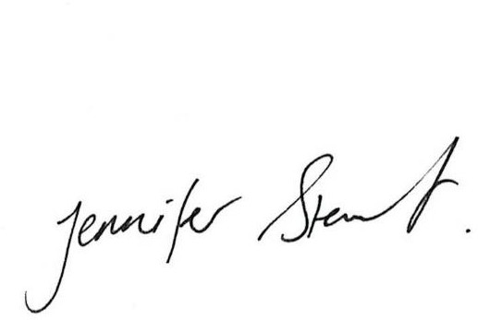
Should you have any questions please email recruitment@rasacpk.org.uk.
Yours sincerely

Jen Stewart
Centre Manager RASAC P&K

CVs

Guidance Notes for Job Applicants

RASAC P&K does not accept CVs as applications for any post (paid or voluntary).

Application Guidance
In the pack that these guidance notes came with you have been provided:

A covering letter Guidance Notes
Information about RASAC P&K
Strategic Priorities
Job Description and Person Specification

The following documents can be downloaded separately and should be returned upon applying:

An application form Data Policy (to sign)
A confidential equal opportunities monitoring form and a confidential disclosure form (please ensure these are completed and returned to us. Both of these will be treated as confidential)

Please read all of this information carefully before completing the application form.

In order to get shortlisted, you must demonstrate with examples how you meet the criteria outlined on the person specification. Please provide specific examples of your skills, knowledge and experience against each of the criteria (this could be paid or unpaid work).

Education/qualifications
Any professional or academic qualifications that you hold that may enhance these posts will be greatly valued. However, success in these posts is determined by the drive, interest and commitment of the candidate to invest in our mission, vision and values through the services of RASAC P&K. We welcome applications from women who meet all of the other criteria outlined without formal qualifications who can demonstrate an engagement with lifelong learning and personal development.
Please let us know about all your most recent training and personal development experiences, including non-accredited learning and courses you have undertaken

Recruitment process
The deadline for completed applications is 12 noon, Wednesday 9th June 2021.

We will contact successful applicants by email to invite them for interview following the shortlisting process.

References
Please supply full contact details for the referees. If you are in paid employment, your current employer should be named as the first referee as someone we can approach for a reference. They will be taken up when we have identified a successful applicant.

About the Centre

Information about RASAC P&K

Our Centre is based in central Perth, but provides a service across Perth & Kinross. RASAC P&K is a member Centre of Rape Crisis Scotland and we are committed to providing consistent and holistic support to female survivors, young people and their supporters across Perth & Kinross.

What we do
RASAC P&K provide a free and confidential support and advocacy service to women, young people (boys 12-18) and families affected by sexual violence. We provide helpline, face to face, email, group and letter support. We also offer support and information to family, friends and partners of survivors. We have a resource library and provide a space to access this upon request.

RASAC Youth Initiative (RYI) is a project within RASAC P&K which delivers a range of age appropriate prevention workshops to young people age 12-18. RYI deliver workshops across a variety of community and educational settings.

To find out more information about our Prevention Work please visit: Prevention | Rape Crisis Scotland. Further information can also be found on our website: https://www.rasacpk.org.uk/young-people-ryi/.

Our Mission: Working Together to End Sexual Violence

Our Visions
At RASAC (P&K) we work towards our mission through our ongoing commitment to the following visions…

Prevention: To change societal attitudes and beliefs through awareness raising events, campaigns and education.
Working in collaboration with relevant agencies to eliminate gender based violence against women.
Protection: Creating a safe environment where women can freely express themselves.
Provision: To continually grow and adapt our services in response to those who need us.
Participation: Overcoming all barriers to give survivors a voice through the promotion of service user involvement.

Our Values
Our core values underpin everything that we do. They lie at the heart of our visions and it is with these values that we believe RASAC (P&K) will be successful in continually developing and adapting services in order to achieve our mission.

We believe that all women, young people and children, regardless of ethnic background, culture or sexuality, should have access to non-judgemental, confidential support at any given time.
We believe that no woman, young person or child, regardless of behaviour, dress or lifestyle is to blame for any form of rape, sexual abuse or sexual assault.
We believe that it is everyone’s responsibility to adopt zero tolerance to any form of rape, sexual abuse and sexual assault of any woman, young person or child.

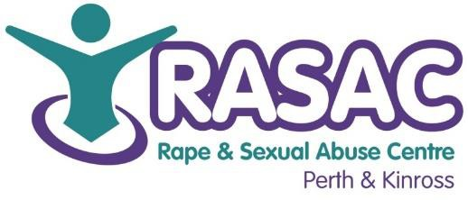

RASAC P&K Strategic Priorities

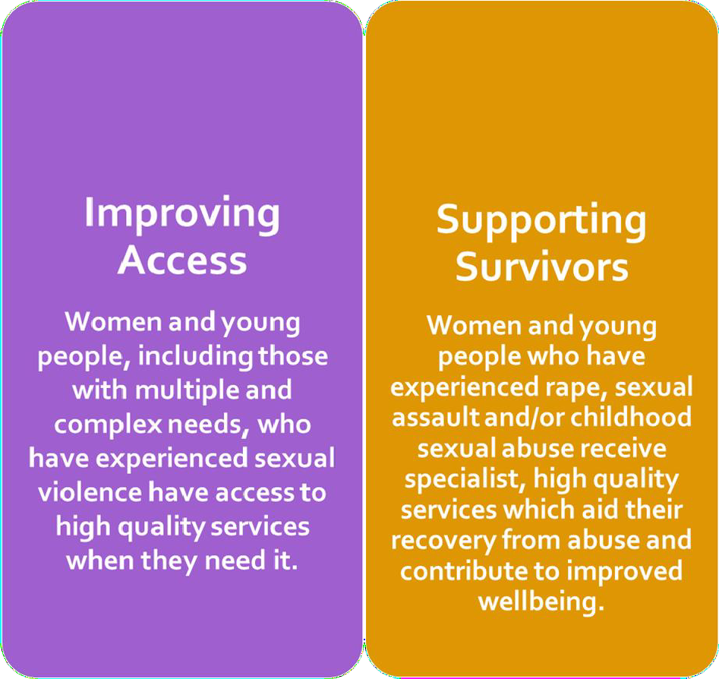

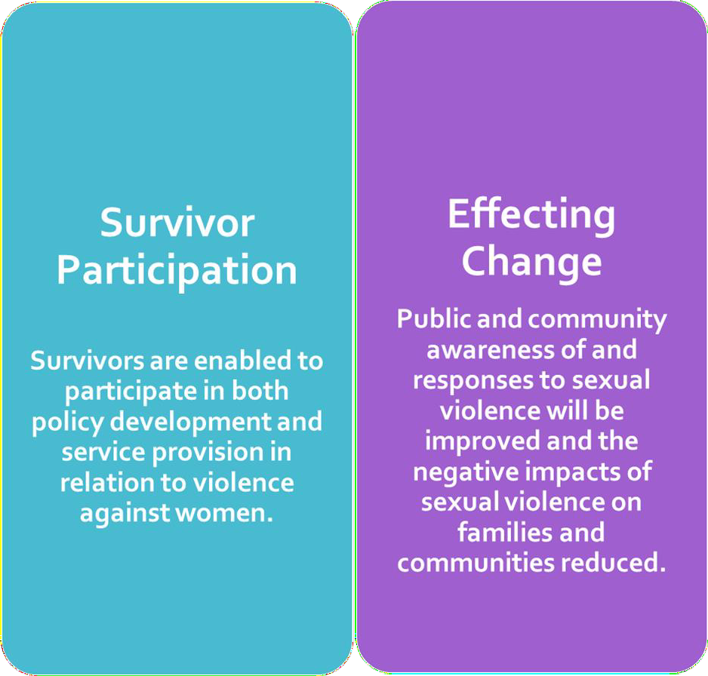

Job Description

Sexual Violence Prevention Worker
This post is restricted to female applicants only (exempt under Schedule 9, Part 1 of the Equality Act 2010)

Responsible to | Prevention Services Team Leader
Responsible for | The successful delivery of RASAC Youth Initiative activities throughout Perth & Kinross.
Role Purpose | To increase young people’s awareness about sexualisation, sexual exploitation and sexual violence. To support young people in the identification and management of risk, and access support services as appropriate. To raise awareness about the prevalence and impact of abuse on individuals and our communities, building resilience and increasing access to support services. This role will involve:  - The delivery of a sexual violence prevention education programme to young people across a variety of educational and community settings in Perth & Kinross.  - The promotion of active citizenship and training opportunities through the development and facilitation of RASAC’s Youth Ambassador programme.  - Working effectively with a range of stakeholders to promote key prevention messages and identify possible development opportunities.  - The delivery of training and talks to groups of professionals, parents and carers as required.
Based | Perth, covering Perth & Kinross (regular evening and occasional weekend work required)
Hours | 35 hours per week
Salary | £27848 ( Expenses incurred through work travel will be re-imbursed)
Length of Post | Funding for this position is indicative to June 2022. RASAC P&K will endeavour to secure ongoing funding beyond this date.
Pension | RASAC P&K offers a 5% pension contribution into an established auto-enrolment pension scheme. To be eligible for employer contributions, employees must contribute a minimum personal contribution of 5%.
Annual leave | 30 days plus 11 public holidays (pro-rata)
Supervision | Monthly support & supervision will take place with the RYI Team Leader.
Closing date for application | 12 noon, Wednesday 9th June 2021

Full PVG checks will be required for this role.

Job Description

Principal Duties

- To work within a feminist, survivor-centred approach at all times
- To develop and deliver a range of workshops in schools and youth projects throughout Perth & Kinross.
- To develop and deliver training and information packs for use with teachers, parents and youth workers.
- To work on a community outreach basis as necessary, delivering sessions to a range of youth settings, including those with complex vulnerabilities
- To ensure that any response to disclosure by a young survivor is dealt with appropriately and in line with the Centre’s Safeguarding Procedures
- Shape service provision in consultation with young people and promote co-production opportunities.
- Liaise with key services to source/develop resources, workshops and campaigns which will increase understanding of the impact of VAW and the links with gender inequality, CSE
- To engage in, and promote, multi-agency and partnership working with a comprehensive range of agencies and organisations

- To record all information pertaining to RASAC P&K’s Youth Initiative accurately and appropriately in line with RASAC P&K’s service information recording and Data Protection systems.
- To implement relevant monitoring and evaluation systems which capture both quantitative and qualitative information from all aspects of the RASAC P&K Youth Initiative.
- To produce comprehensive individual quarterly reports on project outcomes.
- Regular liaison with the Prevention Services Team Leader to plan, review and develop service provision to more effectively meet the needs of survivors.

- Implement and adhere to the Rape Crisis Scotland National Service Standards and Best Practice Model
- Adhere to good practice and contribute to the development of services in accordance to standards set out within the LGBTI Transgender Inclusion Charter and RASAC P&K’s LGBTI Inclusion Plan
- To ensure that all activities comply with current legislation (including safeguarding and health and safety) and with organisational policies and procedures.

Other

- To work as part of a team
- To communicate effectively (written, electronic and verbal)
- To attend individual supervision, team meetings and practice development meetings.
- To contribute positively to the overall mission, vision and values of RASAC P&K.
- Flexibility of working hours (including weekend and evening work – currently regular times are Monday evenings fortnightly and one Sunday per month for 3 hours, although this is subject to change in line with events calendar and the needs of young people accessing services)

This job description is not exhaustive and the post holder may be required to fulfil other responsibilities and tasks in line with the needs of the service.
Sexual Violence Prevention Worker Person Specification

Criteria |  | Essential |  | Desirable
Knowledge & Skills |  | Ability to clearly articulate an understanding and commitment to a feminist analysis of gender based violence |  | Knowledge of the third sector and its role in addressing Violence Against Women  Knowledge and Understanding of Scottish legislation, policy and government strategy related to violence against women
Knowledge of the impact that sexual violence has on
women, young people, children and communities
 |  | Knowledge and understanding of child sexual exploitation, including common risk factors and effective risk assessment
 |  | Knowledge and understanding of the GIRFEC framework in supporting the wellbeing of children and young people
 |  | Excellent organisational skills
 |  | Capable of using own initiative and meeting tight deadlines
 |  | Skilled in use of IT for self-administration e.g., Microsoft, excel, email and internet
Experience |  | Experience of developing and delivering workshops / group work for young people |  | Experience of providing emotional and practical support to young people or families affected by trauma.  Experience of working with volunteers.
 |  | Experience of assessing risk and following child / adult protection procedures as necessary
 |  | Experience of creative monitoring and evaluation processes
 |  | Experience of working with a range of statutory and voluntary partners
 |  | Experience of youth engagement across a range of settings
 |  | Experience of report writing and action plans
Personal Qualities |  | A high level of commitment to the values and ethos of  RASAC P&K
Demonstrates personal integrity with a ‘can do’ positive
attitude
Demonstrates a resilient approach to the workplace, with
clear strategies for managing self
Commitment to modelling feminist values and promoting
equality and diversity
Qualifications |  |  |  | Rape Crisis Scotland Sexual Violence Training Programme  HND level or above in Social Sciences, Community Education, Youth Work or similar discipline.
Other |  | - Ability to work flexibly and to do evening and weekend meetings as required by the needs of RASAC P&K  - Hold a current clean driving license and have access to a car with business insurance  - Ability to drive regularly across Perthshire

